Design and Implementation Specification
for
EVS Grid service for caGrid 1.0

Last Updated: November 8, 2006

Owner: Avinash Shanbhag
Telephone:(301) 540 5171
Email: shanbhak@mail.nih.gov

National Cancer Institute Center for BioInformatics
6116 Executive Blvd.
Rockville, MD 20852



1 Document Purpose 4
2 Implementation Overview 5
2.1 Team Members 5
2.2 Description 5
2.3 Scope 5
2.4 Architecture 6
2.4.1 EVS Grid Service Class Diagram 6
2.4.2 EVS Grid Service Sequence Diagram 7
2.5 Assumptions 8
2.6 Dependencies 8
2.7 Issues 8
2.8 Third Party Tools 8
3 Implementation Contents 9
3.1 Server 9
3.1.1 Algorithms 9
3.1.2 Batch Processes 9
3.1.3 APIs 9
3.1.3.1 getMetaSources 9
3.1.3.2 getVocabularyNames 9
3.1.3.3 searchDescLogicConcept 10
3.1.3.4 getHistoryRecords 11
3.1.3.5 searchMetaThesaurus 12
3.1.3.6 searchSourceByCode 12
3.1.4 Error Handling 13
3.1.5 Database Changes 14
3.2 Client 14
3.2.1 JSP/HTML 14
3.2.2 Servlet 14
3.2.3 Error Handling 14
3.3 Security Issues 14
3.4 Performance 14
3.5 Internationalization 14
3.6 Installation / Packaging 14
3.7 Migration 14
3.8 Documentation Considerations 14
4 Unit Testing 15
4.1 Test Guidelines 15
4.2 Test Cases 15
4.3 Test Results 15
DOCUMENT CONTROL 16
DOCUMENT APPROVAL 17

List of TABLES
Table 2 – Team Members 5
Table 3 – Implementation Specification Document Change Log 14

Document Purpose

This document provides the detailed design and implementation of Enterprise Vocabulary Service (EVS) caGrid Service that will be deployed as part the caGrid 1.0 infrastructure.

The EVS caGrid service will allow programs to utilize the caGrid 1.0 infrastructure to access EVS information that is currently being produced by NCICB.

Implementation Overview

Team Members
Table 1 – Team Members
Role | Name
Development Lead | Avinash Shanbhag
Documentation Lead | Wendy Erickson-hirons
Project Manager | Arumani Manisundaram
Test Lead | Avinash Shanbhag

Description
The EVS grid service will be used to obtain data accessible via the caCORE 3.1 service. Please refer to the caCORE technical guide (Chapter 4: Enterprise Vocabulary Service) [1] for details on the caCORE 3.1 EVS APIs.

Scope
The EVS Grid service will provide programmatic access to the EVS domain objects that are available via the EVS information model.

The EVS grid service will be registered in Cancer Data Standards Repository (caDSR) under the following category:

EVS Grid Service
Context | caBIG
Classification Scheme | caGrid
Version | 1.0

The EVS grid service will provide access to the EVS information model registered in the caDSR under the following category:

EVS Information Model
Context | caCORE
Classification Scheme | caCORE
Version | 3.1

The following APIs will be made available thru the EVS grid service:

Name of the Operation | Comments | Inputs For the Operation | Returned Information from the Operation
searchDescLogicConcept | Searches a valid Vocabulary such as NCI Thesaurus and returns Description Logic concepts that meet the search criteria | The EVSDescLogicConceptSearchParams will contain Vocabulary Name, the search term and the maximum limit of returned objects | Array of DescLogicConcept objects
searchMetaThesaurus | Searches NCI meta thesaurus and returns Meta Thesaurus information that meet the search criteria | The EVSMetaThesaurusSearchParams will contain the search term, the CUI, source, short response, score and the maximum number of returned objects | Array of MetaThesaurusConcept objects
getHistoryRecords | Searches a valid vocabulary in NCI thesaurus for history information | The EVSHistoryRecordsSearchParams will contain vocabulary name and the concept code for which the history information is searched | Array of HistoryRecord objects
getVocabularyNames | Returns all the vocabularies present in the Description Logic | No Input | Array of DescLogicConceptVocabularyName objects
getMetaSources | Used to obtain Meta thesaurus sources | No Input | Array of Source objects
searchSourceByCode | Searches the Meta Thesaurus based on Source code | The EVSSourceSearchParams will contain Source code and abbreviation | Array of MetaThesaurusConcept Objects

The API will access the following objects and from the caCORE 3.1 EVS information model:
- DescLogicConcept
- MetaThesaurusConcept
- HistoryRecord

The following objects are registered by the EVS grid service information model:
- DescLogicConceptVocabularyName
- EVSDescLogicConceptSearchParams
- EVSHistoryRecordsSearchParams
- EVSSourceSearchParams

Architecture

EVS Grid Service Class Diagram

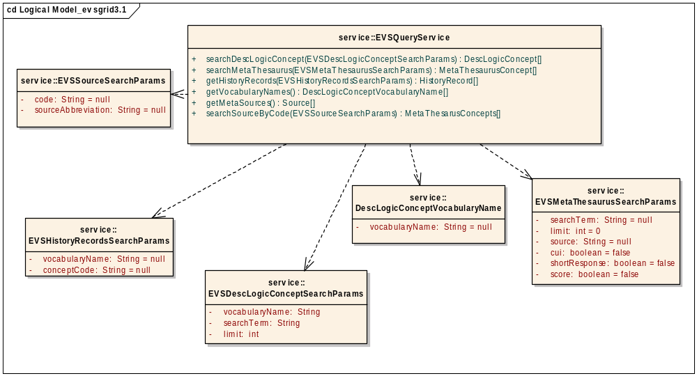

EVS Grid Service Sequence Diagram

The sequence diagram for the operation “getMetaSources” is described below:

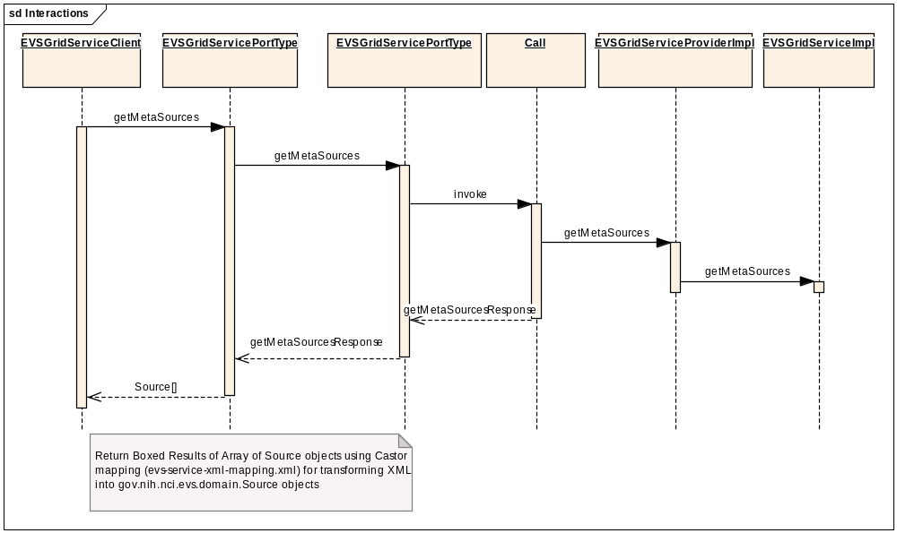

The same classes will be interacting for all the operations in the service.

Assumptions
- The EVS service will be based on the latest caCORE 3.1 patch release built by NCICB before caGrid 1.0 code freeze
- The caCORE 3.1 patch release will be available and deployed at NCICB at the following URL: http://cabio.nci.nih.gov/cacore31/http/remoteService
- The caCORE 3.1 EVS domain model will be loaded in GME in the following namespace: gme://caCORE.caCORE/3.1/
- The EVS service will not have any method level security. All security requirements will be handled by the actual deployment of the underlying caCORE 3.1 EVS service
- The EVS service will be deployed as a “core” service by caGrid 1.0 at NCICB

Dependencies
- caCORE 3.1 EVS service needs to be available and running correctly
- The caCORE 3.1 EVS domain model needs to be registered in caDSR
- The EVS service input classes needs to be registered in caDSR
- The EVS service and operations will use the Introduce toolkit to generate the appropriate structure for registering the service into caDSR
- A concept code for “core” Grid service will be provided by the EVS team

Issues
- None

Third Party Tools
- Introduce Toolkit
- Globus Toolkit (4.0.2 or appropriate version supported by caGrid 1.0)
- caGrid 1.0 core infrastructure

Implementation Contents

Server
The EVS grid service will be deployed as a core grid service at NCICB.

Algorithms
None

Batch Processes
None

APIs

getMetaSources

Input:
None

Output:
gov.nih.nci.evs.domain.Source[]

Exception:
RemoteException

Description:

This method will return an array of gov.nih.nci.evs.domain.Source objects that are published by the caCORE 3.1 EVS service.

Implementation Details:

The API will use the caCORE 3.1 API to query the EVS service as follows:

Step 1: Connect to the caCORE 3.1 service running at NCICB

appService = ApplicationServiceProvider.getRemoteInstance(EVSConstants.CACORE_31_URL);

Step 2: Build a gov.nih.nci.evs.query.EVSQueryImpl object and set the operation as “getMetaSources” as follows:

EVSQuery metaSearch = new EVSQueryImpl();
metaSearch.getMetaSources();

Step 3: Invoke the EVS search API on the caCORE 3.1 service as follows:

Results = (List)appService.evsSearch(metaSearch);

getVocabularyNames
Input:
None

Output:
gov.nih.nci.cagrid.evs.service.DescLogicConceptVocabularyName []

Exception:
RemoteException

Description:

This method will return an array of gov.nih.nci.cagrid.evs.service.DescLogicConceptVocabularyName objects that contain the vocabulary names that are supported by the caCORE 3.1 EVS service.

Implementation Details:

The API will use the caCORE 3.1 API to query the EVS service as follows:

Step 1: Connect to the caCORE 3.1 service running at NCICB

appService = ApplicationServiceProvider.getRemoteInstance(EVSConstants.CACORE_31_URL);

Step 2: Build a gov.nih.nci.evs.query.EVSQueryImpl object and set the operation as “getVocabularyNames” as follows:

EVSQuery evsSearch = new EVSQueryImpl();
evsSearch.getVocabularyNames();

Step 3: Invoke the EVS search API on the caCORE 3.1 service as follows:

Results = (List)appService.evsSearch(evsSearch);

searchDescLogicConcept
Input:
gov.nih.nci.cagrid.evs.service.EVSDescLogicConceptSearchParams

Output:
gov.nih.nci.evs.domain.DescLogicConcept[]

Exception:
RemoteException
InvalidInputExceptionType

Description:

This method will return an array of gov.nih.nci.evs.domain.DescLogicConcept objects that are published by the caCORE 3.1 EVS service.

The API will take following input: valid vocabulary name (present in the list from the getVocabularyNames ), a valid search term that either corresponds to the concept “name” or concept “code” and return the appropriate array of gov.nih.nci.evs.domain.DescLogicConcept objects. All the “associated” objects and attributes corresponding to the caCORE EVS 3.1 information model can be navigated, except for the following:

- Instances of gov.nih.nci.evs.domain.EdgeProperties are not populated currently by the EVS 1.0 core service. These objects are used to specify relationship between a concept and its immediate parent when a DefaultMutableTree is generated. And, the EVS 1.0 core service does NOT produce a Tree.
- Instances of gov.nih.nci.evs.domain.Qualifier are not populated by the EVS 1.0 core service.
- Instances of gov.nih.nci.evs.domain.TreeNode are not populated by the EVS 1.0 core service.

Implementation Details:

The API will use the caCORE 3.1 API to query the EVS service as follows:

Step 1: Connect to the caCORE 3.1 service running at NCICB

appService = ApplicationServiceProvider.getRemoteInstance(EVSConstants.CACORE_31_URL);

Step 2a: Determine if the search term set in the input (EVSDescLogicConceptSearchParams.searchTerm) is a concept code or a name.

Step 2b: If the search term is a “concept code”, then build a gov.nih.nci.evs.query.EVSQueryImpl object and set the operation as “getDescLogicConceptNameByCode” as follows:

EVSQuery evsSearch = new EVSQueryImpl();
evsSearch. getDescLogicConceptNameByCode(EVSDescLogicConceptSearchParams.getVocabularyName(),
EVSDescLogicConceptSearchParams.getSearchTerm()
);

Step 2c: If the search term is a “concept name”, then build a gov.nih.nci.evs.query.EVSQueryImpl object and set the operation as “searchDescLogicConcepts” as follows:

EVSQuery evsSearch = new EVSQueryImpl();
evsSearch. searchDescLogicConcepts (EVSDescLogicConceptSearchParams.getVocabularyName(),
EVSDescLogicConceptSearchParams.getSearchTerm()
);

Step 3: Invoke the EVS search API on the caCORE 3.1 service as follows:
Results = (List)appService.evsSearch(evsSearch);

Note:
It the search term is a “concept code”, then the result from Step 3 is the “name” corresponding to the concept code. This “name” is then used to call Step 2c and Step 3 again to obtain the results.

getHistoryRecords

Input:
gov.nih.nci.cagrid.evs.service.EVSHistoryRecordsSearchParams

Output:
gov.nih.nci.evs.domain.HistoryRecord[]

Exception:
RemoteException
InvalidInputExceptionType

Description:

This method will return an array of gov.nih.nci.evs.domain.HistoryRecord objects that are published by the caCORE 3.1 EVS service.

The API will take following input: valid vocabulary name (present in the list from the getVocabularyNames ) and a valid concept “code” and return the appropriate array of gov.nih.nci.evs.domain.HistoryRecord objects. All the “associated” objects and attributes corresponding to the caCORE EVS 3.1 information model can be navigated.

Implementation Details:

The API will use the caCORE 3.1 API to query the EVS service as follows:

Step 1: Connect to the caCORE 3.1 service running at NCICB

appService = ApplicationServiceProvider.getRemoteInstance(EVSConstants.CACORE_31_URL);

Step 2: Build a gov.nih.nci.evs.query.EVSQueryImpl object and set the operation as “getVocabularyNames” as follows:

EVSQuery evsSearch = new EVSQueryImpl();
evsSearch.getHistoryRecords(EVSHistoryRecordsSearchParams.getVocabularyName(),
EVSHistoryRecordsSearchParams.getConceptCode());

Step 3: Invoke the EVS search API on the caCORE 3.1 service as follows:

Results = (List)appService.evsSearch(evsSearch);

searchMetaThesaurus

Input:
gov.nih.nci.cagrid.evs.service.EVSMetaThesaurusSearchParams

Output:
gov.nih.nci.evs.domain.MetaThesaurusConcept[]

Exception:
RemoteException
InvalidInputExceptionType

Description:

This method will return an array of gov.nih.nci.evs.domain.MetaThesaurusConcept objects that are published by the caCORE 3.1 EVS service.

The API will take following input:
- Valid Meta Thesaurus source abbreviation (present in the list from the API getMetaSources. A value of “*” indicates that the search term will be queried against ALL available sources
- Search term refers to the concept “name” to be searched in the appropriate source or all sources as indicated above
- The appropriate settings of the tuning parameters to indicate whether the search term is a Concept Unique Identifier (CUI) or a regular search term. If the search term is a CUI, then, the search term is validated to adhere to the following restrictions:
  - The CUI begins with the letter “C”
  - The CUI has a maximum length of 8 characters

The API will return the appropriate array of gov.nih.nci.evs.domain. MetaThesaurusConcept objects. All the “associated” objects and attributes corresponding to the caCORE EVS 3.1 information model can be navigated.

Implementation Details:

The API will use the caCORE 3.1 API to query the EVS service as follows:

Step 1: Connect to the caCORE 3.1 service running at NCICB

appService = ApplicationServiceProvider.getRemoteInstance(EVSConstants.CACORE_31_URL);

Step 2: Build a gov.nih.nci.evs.query.EVSQueryImpl object and set the operation as “searchMetaThesaurus” as follows:

EVSQuery evsSearch = new EVSQueryImpl();
evsSearch.searchMetaThesaurus(EVSMetaThesaurusSearchParams.getSearchTerm(),
EVSMetaThesaurusSearchParams.getLimit(),
EVSMetaThesaurusSearchParams.getSource(),
EVSMetaThesaurusSearchParams.isCui(),
EVSMetaThesaurusSearchParams.isShortResponse(),
EVSMetaThesaurusSearchParams.isScore());

Step 3: Invoke the EVS search API on the caCORE 3.1 service as follows:
Results = (List)appService.evsSearch(evsSearch);

searchSourceByCode

Input:
gov.nih.nci.cagrid.evs.service.EVSSourceSearchParams

Output:
gov.nih.nci.evs.domain.MetaThesaurusConcept[]

Exception:
RemoteException
InvalidInputExceptionType

Description:

This method will return an array of gov.nih.nci.evs.domain.MetaThesaurusConcept objects that are published by the caCORE 3.1 EVS service.

The API will take following input:

- A valid Meta Thesaurus source abbreviation (present in the list from the API getMetaSources. The ALL sources value of “*” is NOT PERMITTED for this API.
- A valid value for “code”. Some of the concepts in the Meta Thesaurus do not have code associated with them and are displayed in the NCI Meta Thesaurus Browser with the value of “NOCODE”. The “NOCODE” value is NOT VALID input for the API.

Implementation Details:

The API will use the caCORE 3.1 API to query the EVS service as follows:

Step 1: Connect to the caCORE 3.1 service running at NCICB

appService = ApplicationServiceProvider.getRemoteInstance(EVSConstants.CACORE_31_URL);

Step 2: Build a gov.nih.nci.evs.query.EVSQueryImpl object and set the operation as “searchSourceByCode” as follows:

EVSQuery evsSearch = new EVSQueryImpl();
evsSearch.searchSourceByCode(EVSSourceSearchParams.getCode(),
EVSSourceSearchParams.getSourceAbbreviation());

Step 3: Invoke the EVS search API on the caCORE 3.1 service as follows:
Results = (List)appService.evsSearch(evsSearch);

Error Handling

Error Connecting to caCORE 3.1 Service

All the APIs will throw an exception (java.rmi.RemoteException) if caCORE 3.1 service was unavailable. The following error message will be wrapped into the error “message”
“Error in connecting to the caCORE Service. Please check that the following URI is working correctly: <caCORE 3.1 URL>”

The actual code will be as shown below:
throw new ServiceException("Error in connecting to the caCORE Service. Please " +
"check that the following URI is working correctly: " + EVSConstants.CACORE_31_URL, re);

Input Error

All the APIs that accept “inputs” will also throw the exception (gov.nih.nci.cagrid.evsgridservice.stubs.types.InvalidInputExceptionType) if invalid inputs are passed to the API.
The detailed fault will be described in the “faultString” attribute of the class, as shown below:

InvalidInputExceptionType fault = new InvalidInputExceptionType();
fault.setFaultString("Invalid inputs: EVSSourceSearchParams object cannot be NULL");
throw fault;

Database Changes
None

Client
The Introduce toolkit generates a “client” class that will be provided to the users.

JSP/HTML
None

Servlet
None

Error Handling
None

Security Issues
All the information accessed by the EVS grid service is publicly available from NCICB and users are expected to follow the licensing requirements currently in place for accessing and using NCI EVS information.

Performance
The EVS services will take advantage of all improvements made to the caCORE 3.1 EVS services. However, there will not be any additional performance improvements done to the EVS Grid service.

Internationalization
Not Internationalized

Installation / Packaging
The service needs to be installed as a core grid service. At the least, the base installer for caGrid 1.0 infrastructure will be modified to allow installation and deployment of the EVS grid service.

Migration
No migration changes

Documentation Considerations
The EVS grid service client API will be described in the caGrid 1.0 User Guide and the Programmers Guide.

System Testing
The System test case for the EVS grid service is present in the following package:

Test Guidelines
To be developed

Test Cases
To be developed

Test Results
To be developed

DOCUMENT CONTROL
Change History
Content changes to this document from the previous to the current level are indicated by revision bars (|) unless a complete rewrite is indicated.

Table 2 – Implementation Specification Document Change Log
Version/Date | Approved By | Change Description and Explanation | D - Draft  A - For Review/ Approval  R - Re-Approval, Plan of Record Change
10/2/2006 |  | Initial Version | D
Note: If this document has been inspected, please indicate the inspection date that each version is based on in the “Change Description and Explanation” area. Entries in this log must be maintained for at least 3 years.

DOCUMENT APPROVAL
Approvers List
The individuals listed in this section constitute the approvers list for the Integration Test Plan document. Formal approval must be received from all approvers prior to the initiation of the next steps in the process.

Title | Name
Project Manager | Arumani Manisundaram
Development Manager | Scott Oster

Reviewers List
The individuals listed in this section constitute the reviewers list for the Master Test Plan document. Formal approval is not required from the reviewers, however, it is desirable to have all reviewers review and comment on the document. Reviewers may choose to concentrate on reviewing only those sections that are in their area of responsibility, rather than the entire document.

Title | Name
Technical Writer | Wendy Ericson-hirons

END OF DOCUMENT

